Final Project

MovieDB Search Page

By: Farhan Khan

For: Term Project

Date: 12/07/2017

**Report Overview:**

The Final Project was created in order to display the ability to understand and properly code movieDB API with an existing html file with combining everything we had in the previous milestone using jQuery, JSON, RESTful Web API, AJAX, and SPA UI design. Also as requested, the Final Term Project was created as a separate app. The initial content of the website features a home page with multiple links leading to the Milestones to be delivered. For this case, we have activated the Final Project location from either the navigation bar on the top of the screen, or using the main housing section to access the Final Project.

Once the user has selected the Final Project link from the homepage, from either location, the user will be brought to the main section of the delivery. This is where a user will be able to search for a movie, or multiple movies, using the search function of the page. The search bar will be using the moviedb API to produce the searched query. Once, the user clicks on the Search button, on the page, they will now get a collection of movies, that matches their search criteria. They will only be able to see up to 20 movies, per page, on the page. If the user wants to see more data they can hit the second Result page link, or others, to see more results. They will only be able to see 20 movies at a time.

From here the user can either choose a Grid view or a List view. The Grid view is chosen as the default view. Once the users select the movie that they are interested in, they will be able to see the movie details by clicking the movie and looking at the pop up. From here the user will be able to learn almost everything about the movie with a brief overview, cast members, release date, popularity and more. The Final Project page will also be able to display the top 20 popular movies right now, top 20 top rate movies at the current moment, top 20 new upcoming movies and my own personal collection of movies from moviedb, via the Favorite Movies button.

**Main Homepage URL:** <https://khaoticreaper.github.io/web_projects/index.html>

**Direct Link to Final Project:** <https://khaoticreaper.github.io/web_projects/FinalProject.html>

**Screenshots:**

**Home Page:**

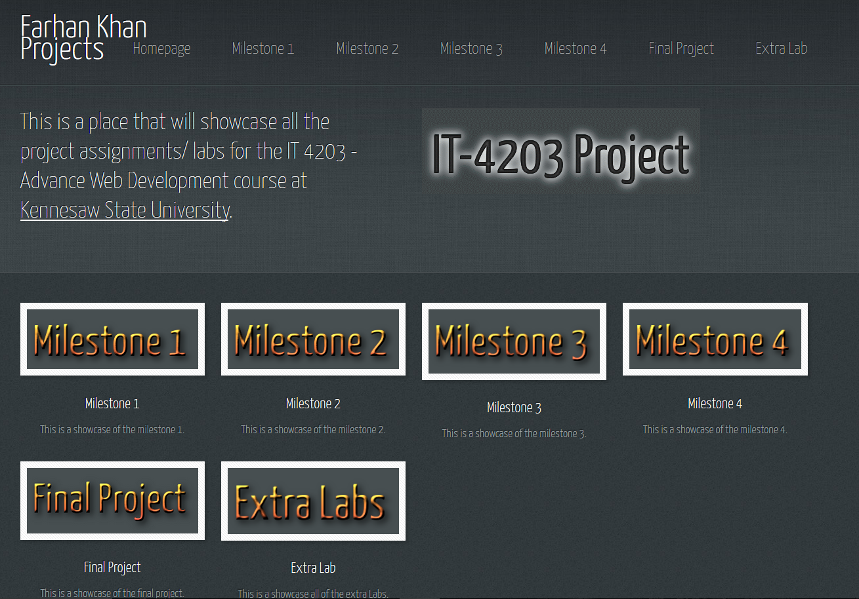

This home page will allow the user to select the Milestones they want to see. This page also consists of a full biography of the creator of the website, myself, and will also show some social media sites on the bottom of the page for contact purposes. On the header side the links of each milestone is working and will remain static throughout the Milestones created. From here, the user can either click on the Final Project showcase, or select Final Project from the top of the navigational pane.

**Final Project:**

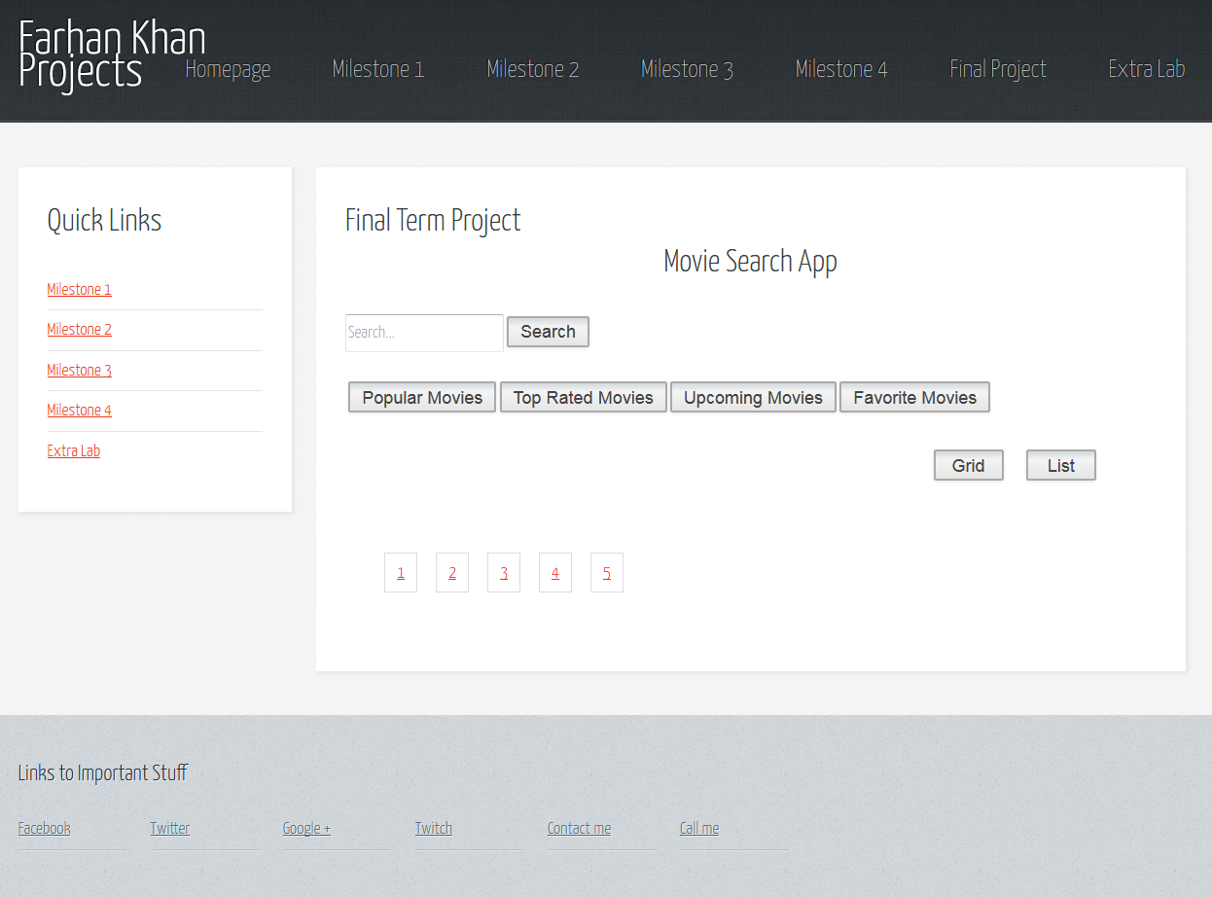

This is the main location of the Final Project site. From here the users will be able to type in any text in the textbox, and when clicked search the user will be able see all the results pushed from the Moviedb API to this section of the site. If the user chooses they can always use the top navigational pane or the quick links on the left hand side to visit the other pages of previous milestones.

**Search:**

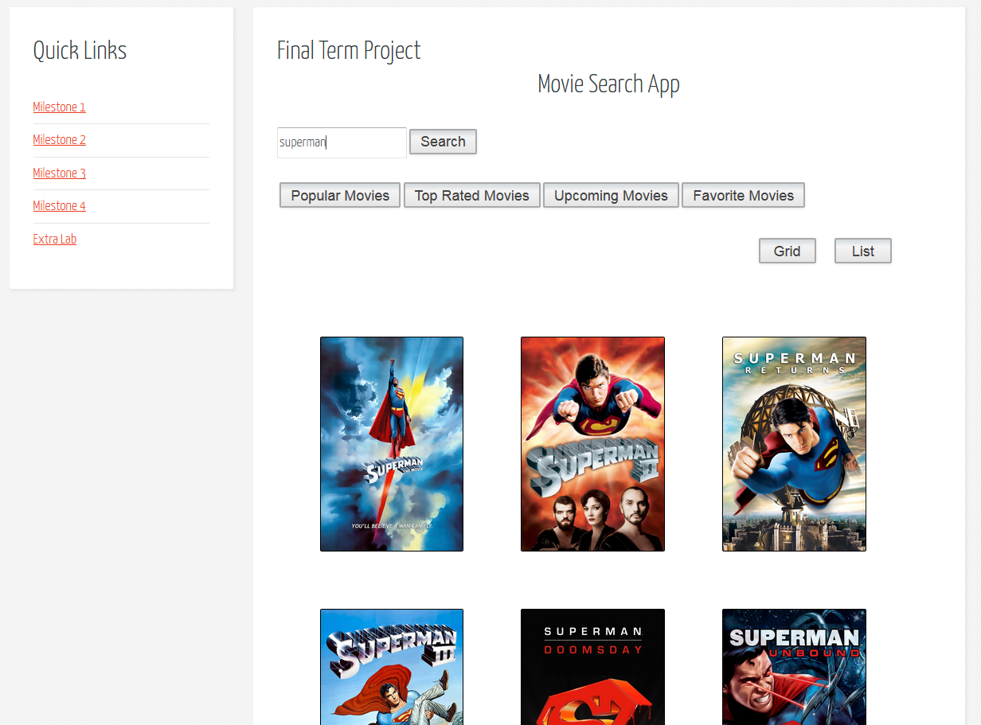

Let’s say that the user wants to search movies for “Superman”, so this user can just type in “Superman” in the search box and click on the search button. Once the search is completed the user will get a variety of movies that are “superman” related. The user is only shown 20 movies at the most, per page, and will have more searches available on the pagination pages below the movies for more to be displayed.

**List View:**

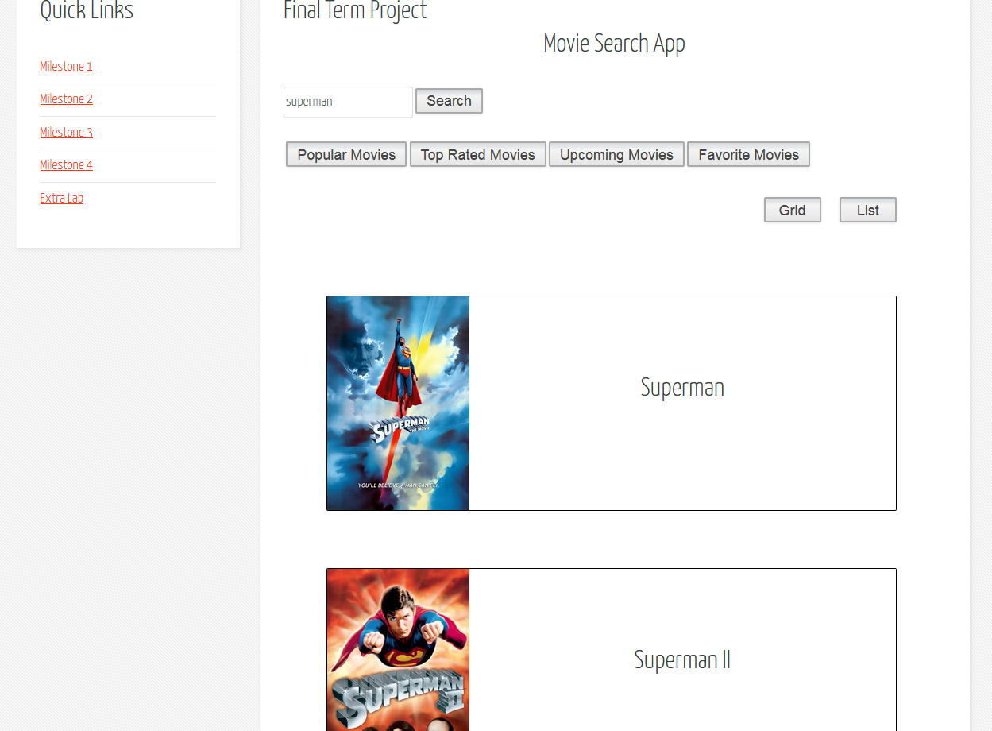

User will be able to choose the type of view they would prefer, a grid or list view. By clicking the list view, since the grid view is the default view, the user will quickly see the change of view for their search results. Here the user can click on the movie they would like to know more information about and will be able to see a detailed information about the movie from the moviedb API.

**Grid View:**



If the user chooses to go back to the grid view, they can just simply click on the Grid button.

**Movie Detail:**

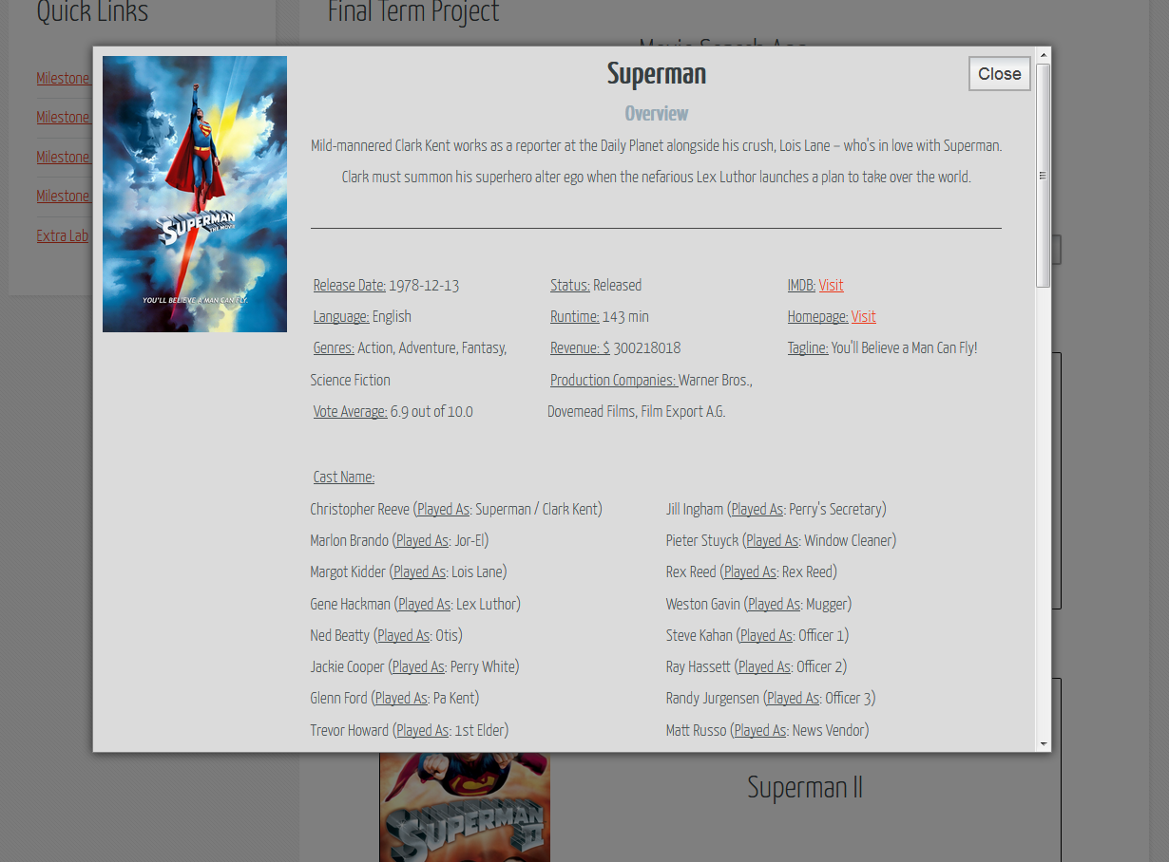

Whether the use is in the grid view or the list view, the user can always click on the picture of the titles and will be able to see a details page with a pop out effect. From here the user can see all types of information including:

1. Title
2. Overview of movie
3. Release Date
4. Genres
5. Votes the movie received on an average
6. Status of the movie
7. Total Runtime
8. Total Revenue made
9. All Production companies involved in making the movie
10. IMDB link
11. Movie homepage
12. Tagline of the movie
13. Cast information

**Cast Full Detail:**

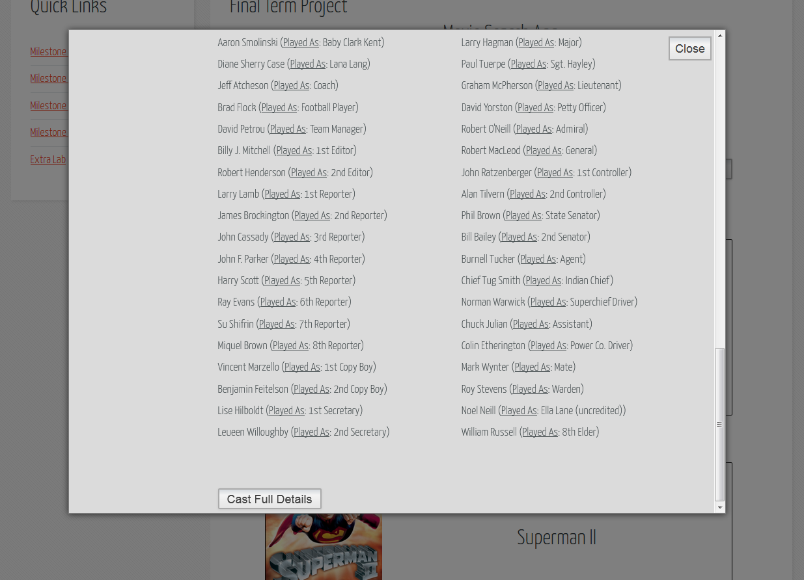

Within the Details page, we have the Cast Full Details button that will take the user to IMDB page where the user will be able to get all kinds of information about the crew and cast members in another tab. Here the user can get biography of the cast members, birthdates, and even information on the guy that was sitting and drinking coffee in one of the scene.

**Pagination:**

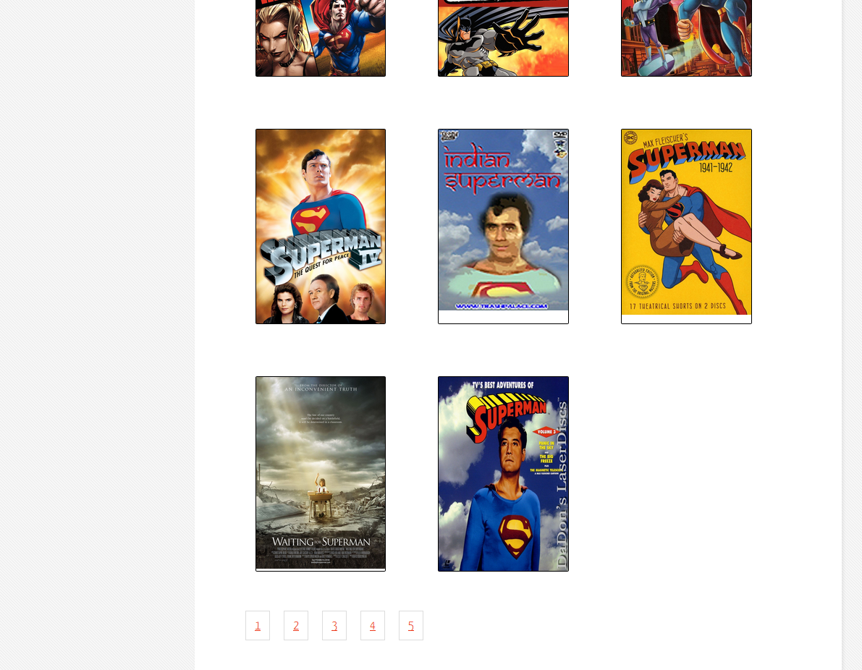

If the user chooses to see more movies that are superman related, they can always click on the paginations on the bottom of the screen that will show them more movies with superman in the context. These buttons will be kept highlighted when the user is on that page, let the user know of the current page that they are on.

**Popular Movie Search:**

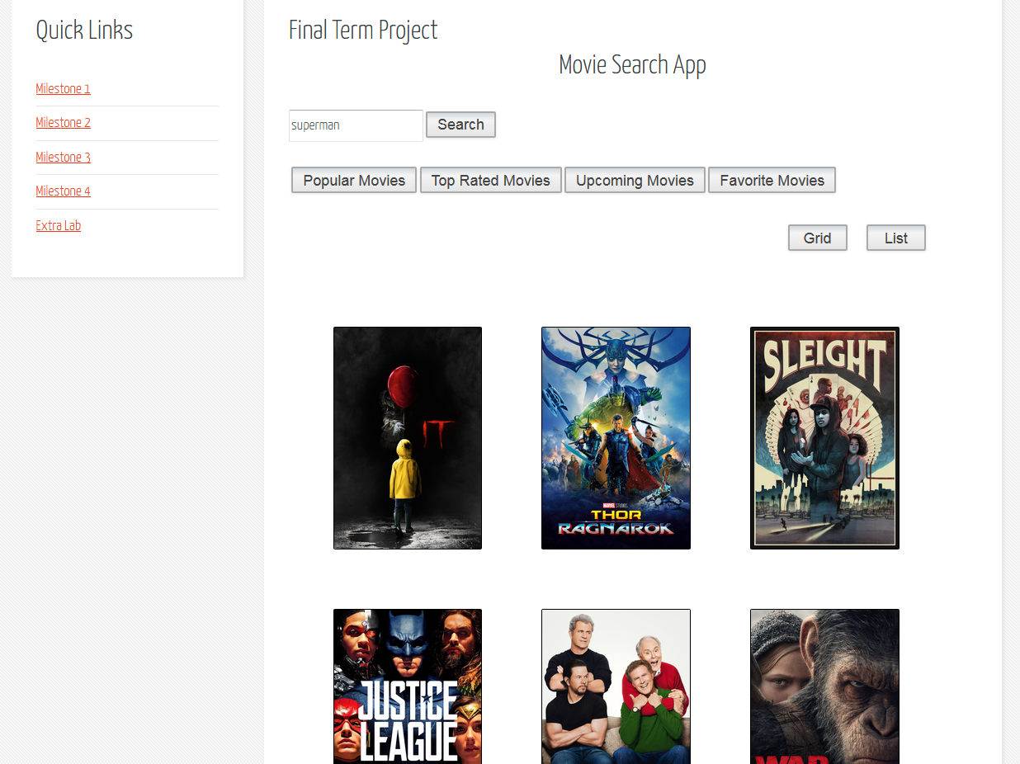

The user can always get the most popular movie in the current present when they are on this page. These are basically filtered by the most popular movie of the current timeframe. Since they are always going to be the most of 20 movies, the pagination will disappear when you are checking out the Popular movies.

**Top Rated Movies:**

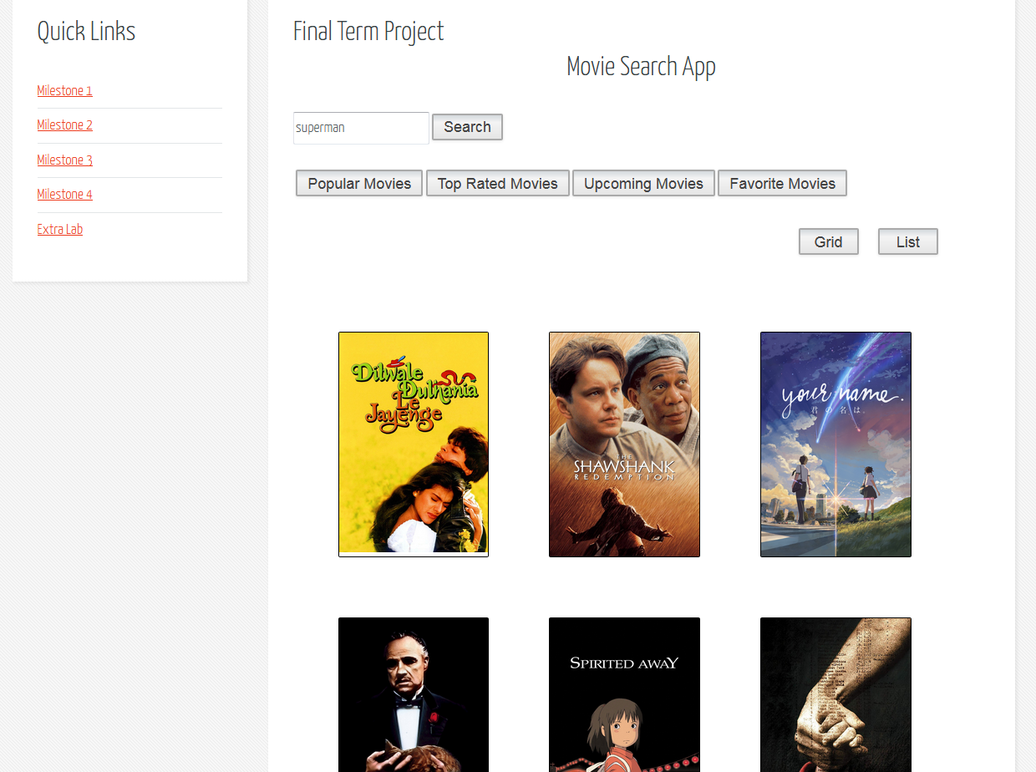

Users, if they choose, they can look at the Top Rated Movies of all time as well.

**Upcoming Movies:**

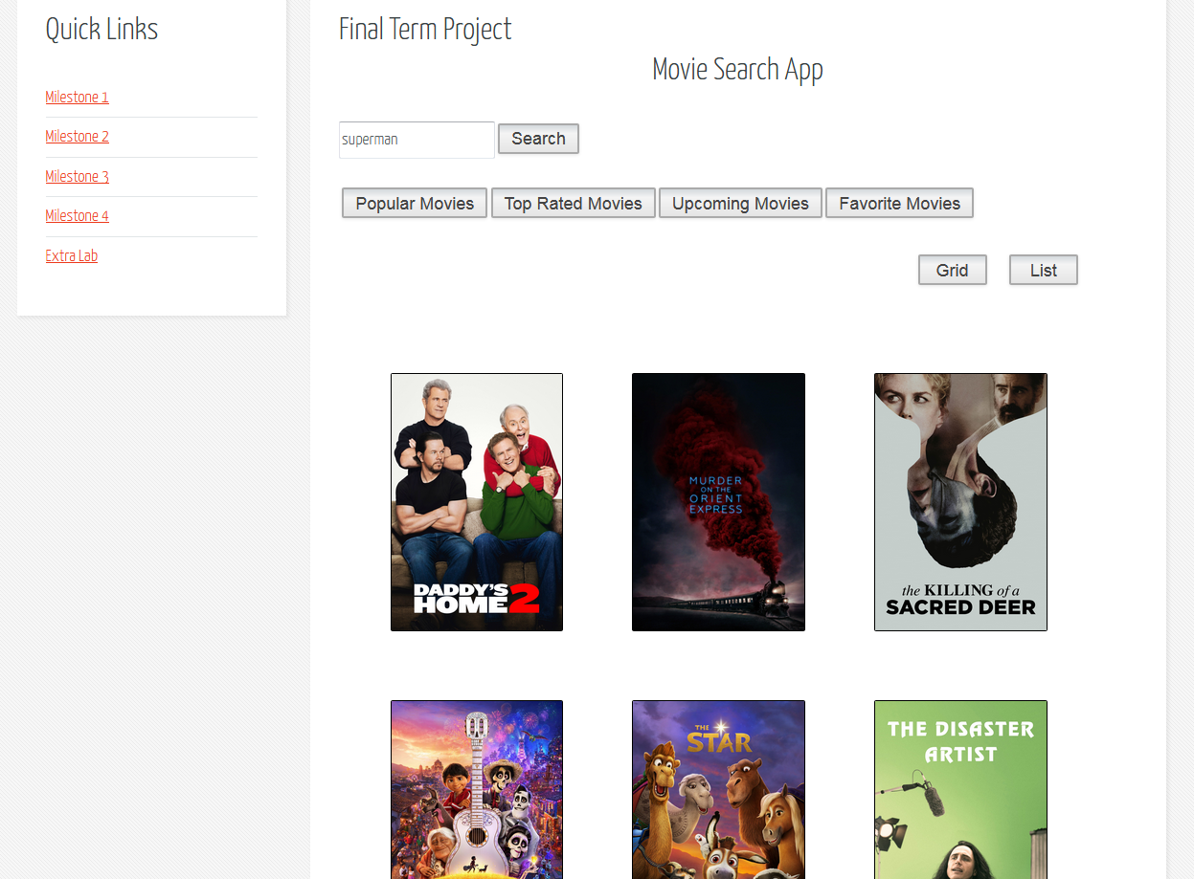

Users can also be updated with any upcoming movies that are about to be released soon. They auto filtered with the soonest movie that is coming out first.

**Favorite Movies:**

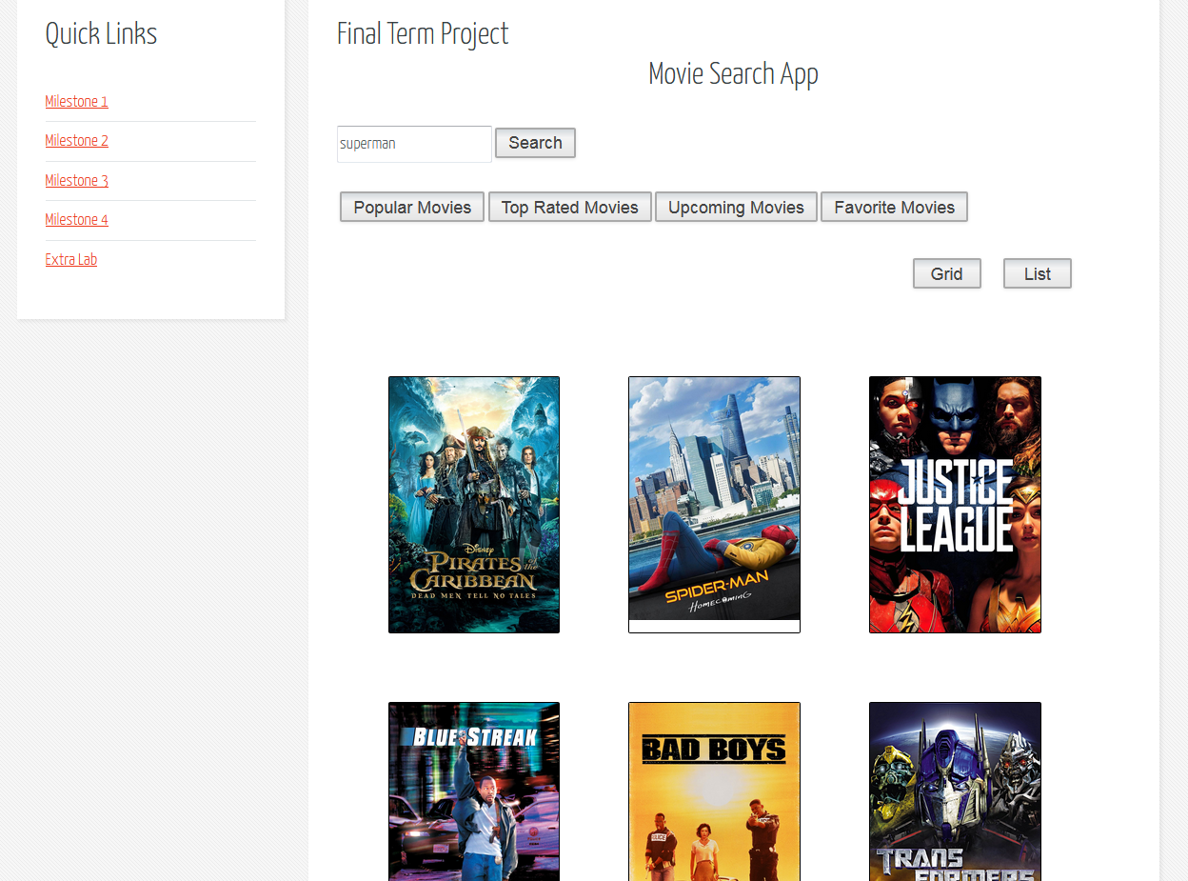

Finally, we have my personal favorites in the Favorite Movies section. Users can look at my personal collection which is also located on the moviedb API.

End of Report